**UNIVERSITY OF PETROLEUM AND ENERGY STUDIES**

**DEHRADUN, UTTARAKHAND**



**2023-2024**

**Software Provisioning and Configuration Management**

**Lab File**

|  |  |
| --- | --- |
| **Submitted By:**  **Name: Mridul Singh**  **Sap id: 500094181**  **Roll No.: R2142210501**  **Batch: Devops B1 H** | **Submitted To:**  **Silky Goyal**  **School of Computer Science** |

**INDEX**

|  |  |  |
| --- | --- | --- |
| **S. No.** | **Experiment** | **Page No.** |
| 1 | Install Terraform | 3 - 4 |
| 2 | Create EC2 instance on AWS using Terraform | 4 - 5 |
| 3 | Create S3 Bucket on AWS using Terraform | 5 - 5 |
| 4 | Create VPC on AWS using Terraform | 6 - 6 |
| 5 | Using Variables in Terraform and create ec2 instances by using variables | 7 - 7 |
| 6 | Install Ansible and write playbook to print “hello world” using Yaml | 8 - 9 |
| 7 | Write ansible playbook to perform certain tasks | 9 - 11 |
| 8 | Write an ansible playbook to print the default ipv4 address and many more task | 12- 14 |

**Experiment - 1**

**Aim: Installing Terraform**

To use Terraform you will need to install it. HashiCorp distributes Terraform as a binary package.

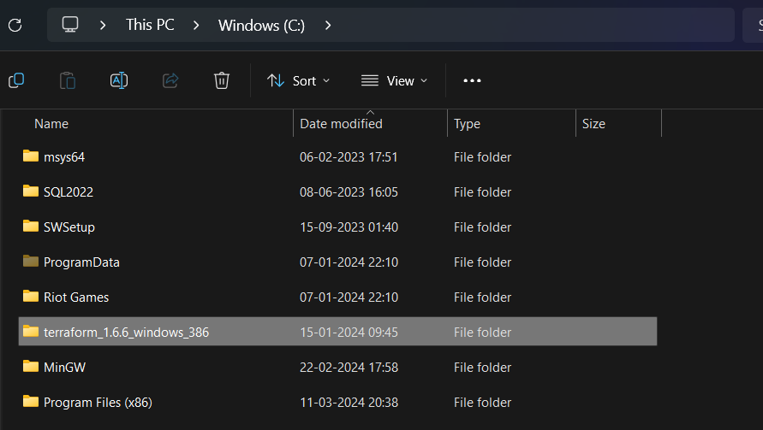

Set Environment Variable for terraform

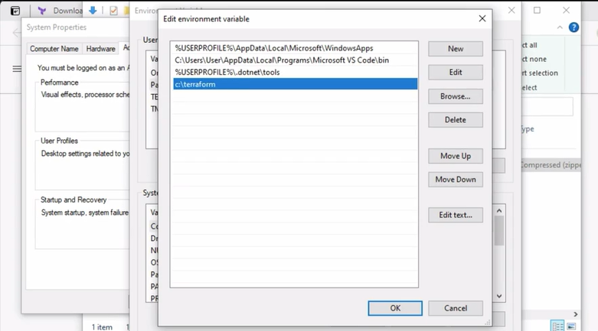

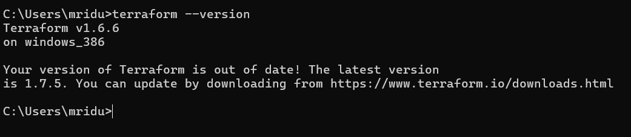

**Experiment – 2**

**Aim: Create EC2 on AWS using Terraform**

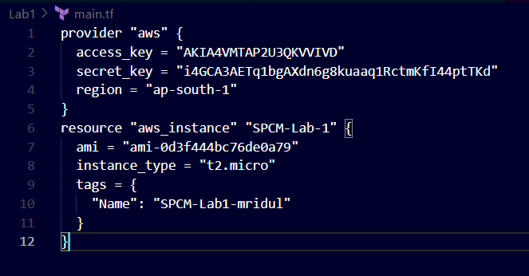

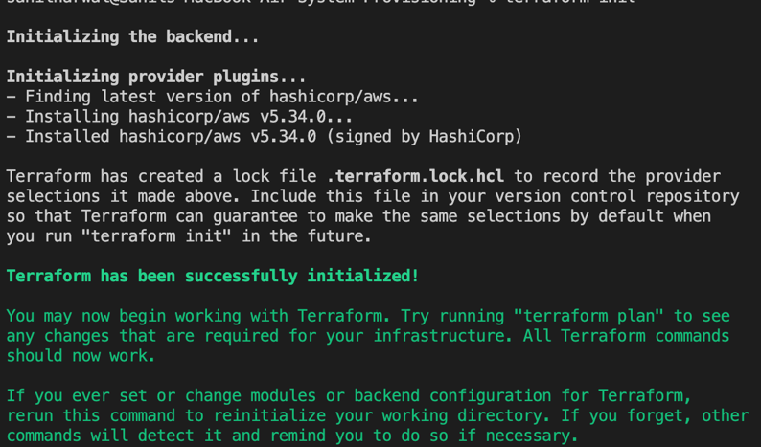

**Experiment - 3**

**Aim: Create S3 Bucket on AWS using Terraform**

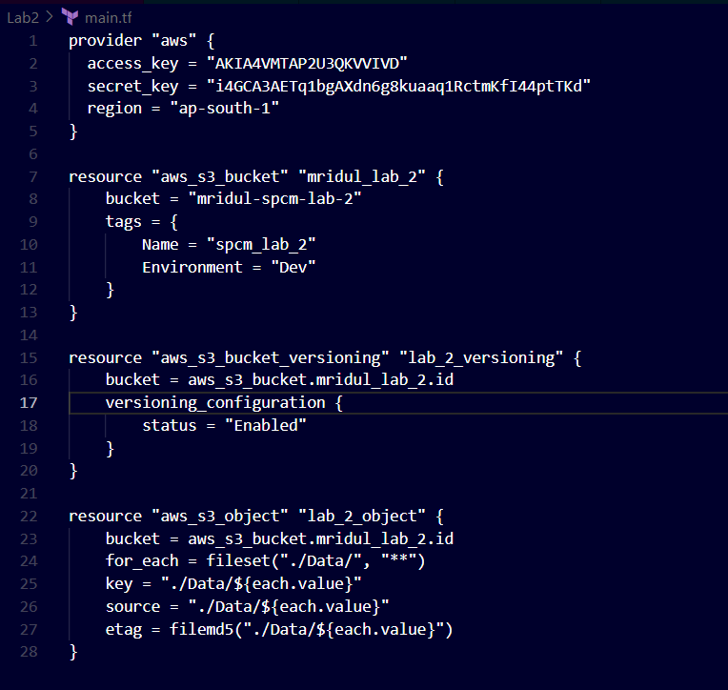

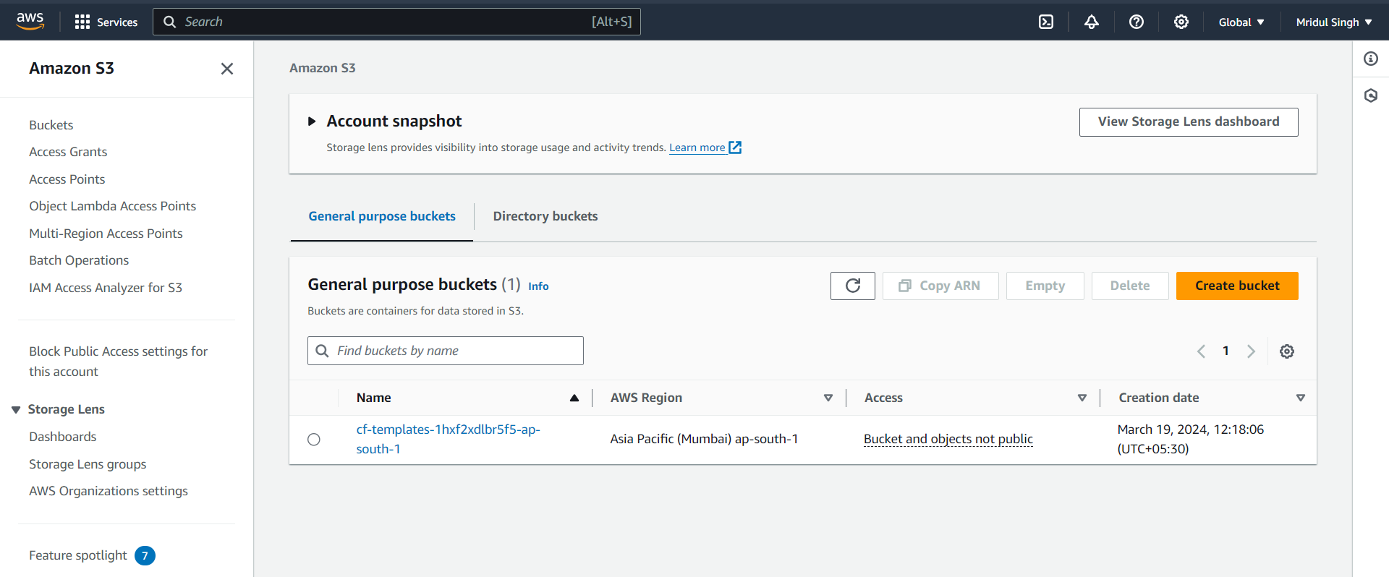

**Experiment - 4**

**Aim: Create VPC on AWS using Terraform**

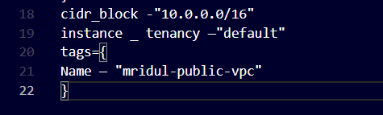

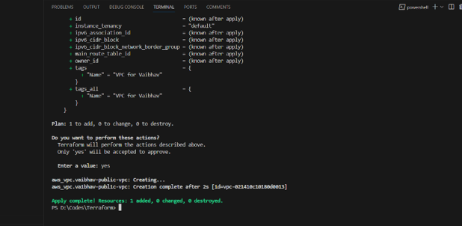

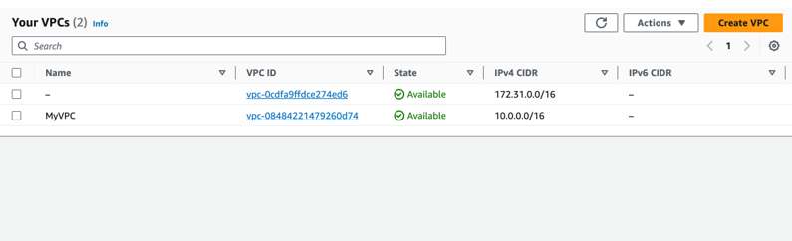

**Experiment – 5**

**Aim : Using Variables in Terraform**

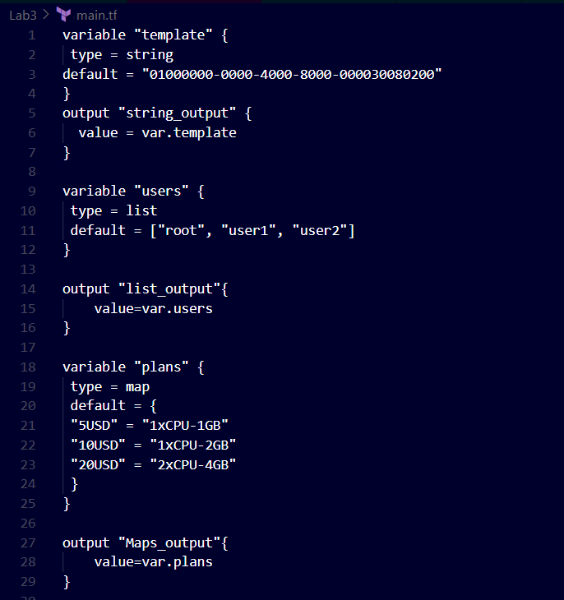

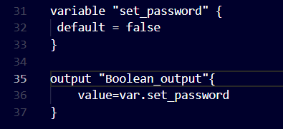

**Experiment – 6**

**Aim: Create 3 ec2 instances by using variables in Terraform.**

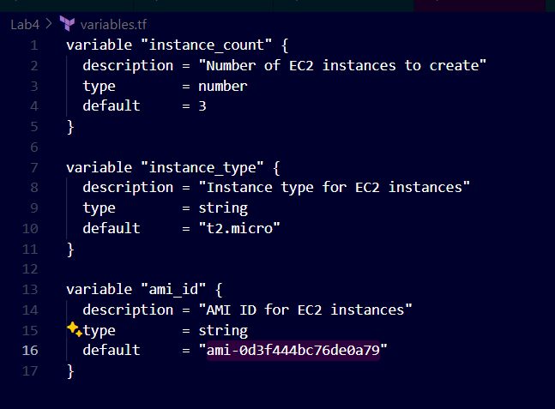

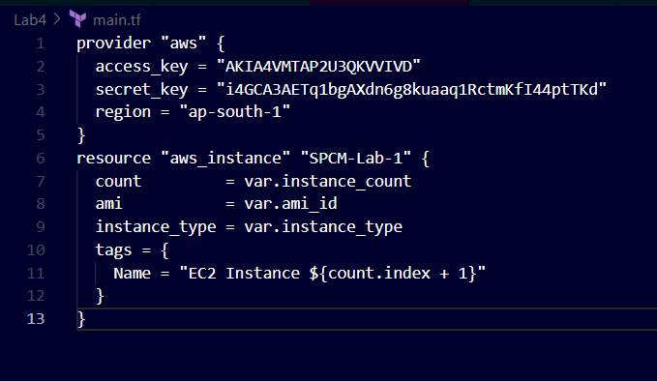

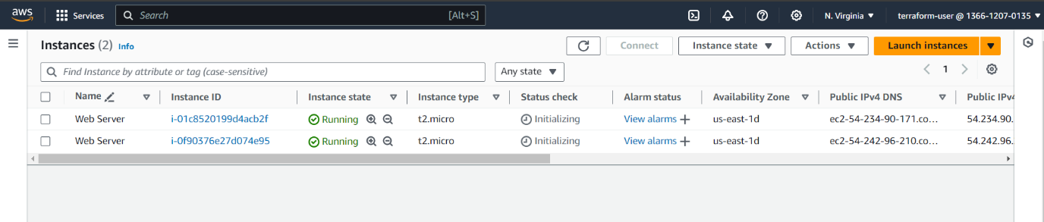

**Experiment – 7**

**Aim:** Ansible installation and basic programs

* **Write the steps for setting up the ansible.**
* **Write an ansible playbook to print “Hello World” using yaml.**
* **Write an ansible playbook to perform shell command using yaml.**
* **Write an ansible playbook to declare the variable using yaml.**

1. **Steps for installation of Ansible**

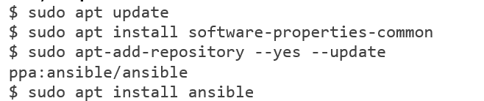

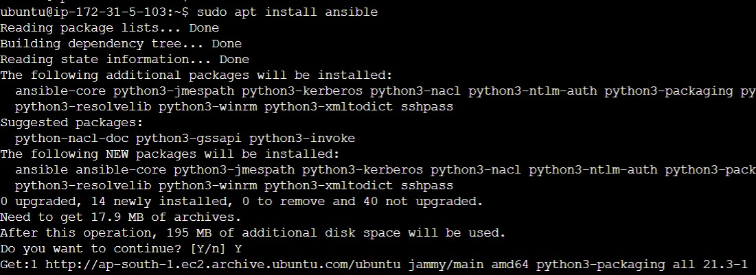

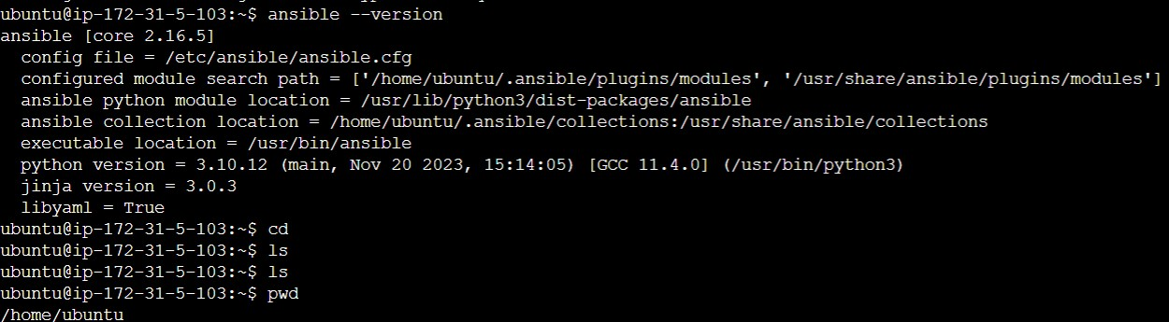

**Print Hello World**

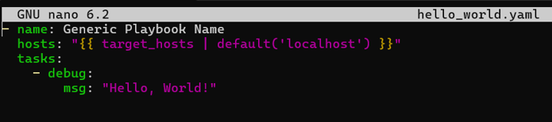

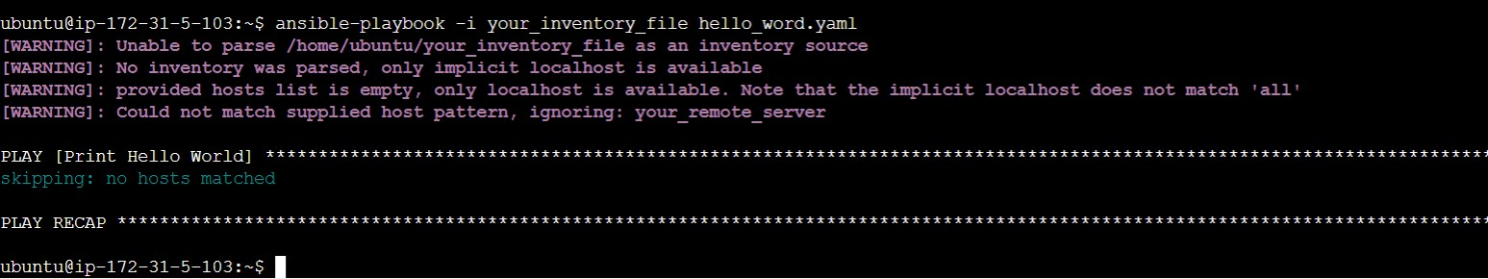

**Execute shell command**

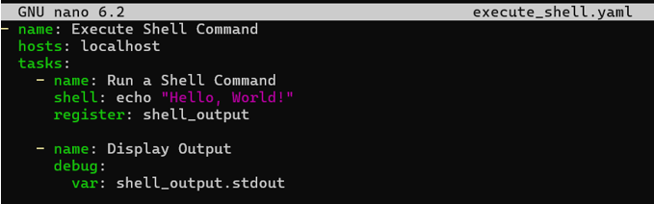

**Declare the variable**

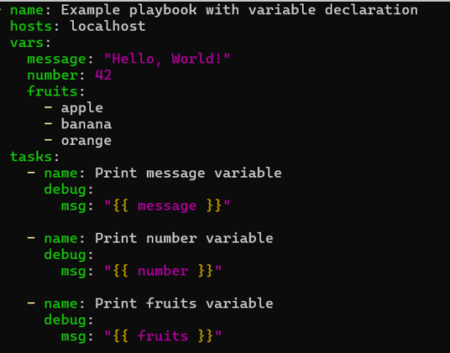

**Experiment- 8**

**AIM:**

* **Write an ansible playbook to print the default ipv4 address of each host along with host name.**
* **Write an ansible playbook to print the user-defined variable from command line.**
* **Write an ansible playbook to pass multiple variables from command line.**
* **Write an ansible playbook to show the working of loops.**

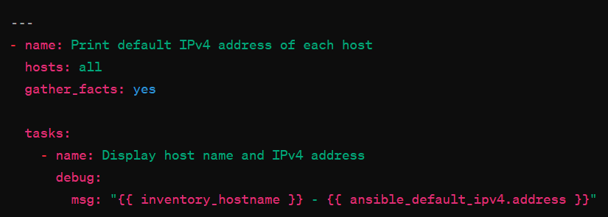

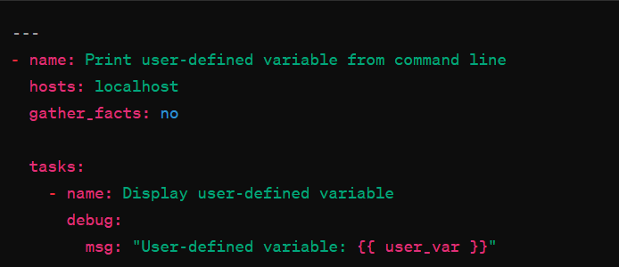

ansible-playbook -i localhost, print_user_variable.yml -e "user_var=my_variable"

